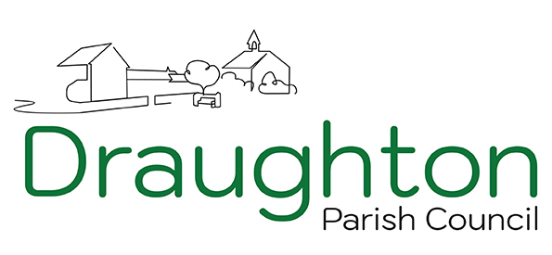

NOTICE OF THE MEETING OF THE COUNCIL TO BE HELD ON MONDAY 2nd March 2026 IN THE VILLAGE HALL AT 7.00PM

A G E N D A

- Welcome from the Chair:
- Apologies – to receive apologies and consider reasons for absence.
- Register of Interests – to confirm interests held in the Register maintained by the Monitoring Officer (Note: all councillors may check copies of their current registration forms available on the website – www.draughton.org)
- Disclosure of interests – to receive any declarations of interests not already recorded in the Members’ Register of Interests, to note any interests relevant to the business of the meeting (whether previously registered or not), and, if so required, to receive and consider applications (if any) for dispensation pursuant to the Council’s Code of Conduct for members with an interest to take part in the discussion and vote on the business in question
- Cllr Richard Neale: The thanks of Council
- Minutes – to confirm the Minutes of the Council Meetings held on 5th January 2026 as a true and correct record (attached)
- Matters arising from Council Meeting – to receive the Clerk’s report for information on matters arising from the meeting held on 5th January 2026.
- Clerk’s Report – to consider the Clerk’s Report on ongoing and outstanding items of business (listed in report attached at item 7 if required), and to decide any action as necessary on matters as listed.
- Planning – to note planning decisions and to decide action as necessary on the following application:
Note: Any additional planning applications received after publication of the agenda but at least 3 clear days (excluding Bank Holidays) before the meeting will be circulated to Members and may be considered at the meeting

- Financial Report 2025/26: Update on expenditure and income. a) Financial Report: April 2025 to February 2026 b) 2026-27 Draft Budget c) Payments and Income January and February 2026
- Open Space:
a) Trees b) Verges
- AGAR 2025-26: Exemption of Fees:
- The Dales Care Home: Visit 12th January 2026
- Parking Issues: Updates
- Police Incidents: Reports received.
- Village Newsletter: Production timetable
- Mobile Library Visits: Update
- Consultations and Correspondence– to note e-newsletters circulated for information, to consider correspondence received, and decide action where necessary on the following matters: a) North Yorkshire Citizens Advice and Law Centre
- Date of Next Meeting – to confirm the date: Tuesday 12ND May 2026 at 7pm in the Village Hall: Annual Meetings

Members of the Council are hereby summoned to attend the meeting. The Press and Public are invited to attend, but the Public are reminded that they are permitted to take part in any discussions only at the discretion of the Chairman of the Meeting.
Councillors and Local Electors wishing to have any issues raised at the meeting are asked to notify the Clerk (preferably in writing) one week before the meeting. At the discretion of the Chairman of the Meeting, any such issues will be included on the Agenda.

